**Table S1.** Drivers of microbial alpha diversity with the random effect of sampling location (Indiana county) to account for potential spatial patterns. Test statistics and p values reported only for  parameters with significant influence on one of the four microbial groups tested either in the 0-5 cm soil depth or 5-10 cm soil depth. Marginal R2 indicates the model fit including  fixed effects only; conditional R2 additionally includes the random effect of county. ICC=Intraclass correlation coefficient.

|  |  |  |  |  |  |  |  |  |
| --- | --- | --- | --- | --- | --- | --- | --- | --- |
|  | **0-5 cm** | | | | **5-10 cm** | | | |
| **Bacteria** | **Total Fungi** | **AM**  **Fungi** | **EM**  **Fungi** | **Bacteria** | **Total Fungi** | **AM**  **Fungi** | **EM**  **Fungi** |
| Total tree richness | - | - | - | - | - | β= -0.23  p= 0.042 | - | - |
| AM dominance | - | - | - | - | - | - | - | - |
| Stand age | - | - | - | β= 0.57  p= 0.027 | - | - | - | - |
| Basal Area Increment | - | - | - | - | - | β= 0.37  p= 0.014 | - | - |
| VertSD | - | - | - | - | - | - | - | - |
| VAI | - | - | - | β= 0.43  p= 0.025 | - | - | - | - |
| VCI | - | - | - | - | - | - | - | - |
| C:N | - | - | - | - | - | - | - | - |
| pH | β= 0.59  p= 0.002 | - | β= 0.43  p= 0.04 | - | β= 0.63  p= 0.013 | - | - | - |
| FeOx (percent) | - | - | - | - | - | - | - | - |
| **Random Effects** |  | | | | | | | |
| ICC | 0.00 | 0.03 | 0.00 | 0.00 | 0.00 | 0.00 | 0.02 | 0.00 |
| Marginal R2 | 0.589 | 0.333 | 0.447 | 0.434 | 0.427 | 0.764 | 0.277 | 0.203 |
| Conditional R2 | 0.589 | 0.333 | 0.447 | 0.452 | 0.427 | 0.764 | 0.294 | 0.203 |

**Table S2.** Relative variation in microbial community composition (beta diversity) explained by structural diversity and individual environmental predictors within variable groups presented in Figure 4. Values calculated using a distance-based redundancy analysis after accounting for spatial arrangement of study plots. X2 and p values are reported only for a predictor that explains significant variation in the community composition at α= 0.05.

|  |  |  |  |  |  |  |  |  |  |
| --- | --- | --- | --- | --- | --- | --- | --- | --- | --- |
| **Group** | **Variable** | **0-5 cm** | | | | **5-10 cm** | | | |
| **Bacteria** | **Total**  **Fungi** | **AM**  **Fungi** | **EM**  **Fungi** | **Bacteria** | **Total Fungi** | **AM**  **Fungi** | **EM**  **Fungi** |
| Structural diversity | Vert SD | - | - | - | Χ2: 12.2  p<0.001 | - | - | - | Χ2: 33.2  p<0.001 |
| VAI | - | - | - | Χ2: 27.4  p<0.001 | - | - | - | Χ2: 37.6  p<0.001 |
| VCI | - | Χ2: 11.2  p<0.001 | - | - | - | - | - | - |
| Tree diversity | Tree richness | - | - | - | Χ2: 49.4  p<0.001 | - | - | - | Χ2: 56.6  p<0.001 |
| AM dominance | Χ2: 12.1  p<0.001 | Χ2: 15.5  p<0.001 | - | Χ2: 29.5  p<0.001 | Χ2: 17.2  p<0.001 | Χ2: 14.7  p<0.001 | Χ2: 22.7  p<0.001 | - |
| Stand properties | BAI | - | - | - | - | - | - | - | Χ2: 89.5  p<0.001 |
| Stand age | - | - | - | Χ2: 13.5  p<0.001 | - | - | Χ2: 12.9  p<0.001 | Χ2: 24.6  p<0.001 |
| Soil properties | C:N | Χ2:7.81  p=0.005 | Χ2: 52.0  p<0.001 | Χ2: 14.6  p<0.001 | Χ2: 333  p<0.001 | Χ2: 38.9  p<0.001 | Χ2: 84.2  p<0.001 | Χ2: 76.3  p<0.001 | Χ2: 188  p<0.001 |
| pH | Χ2: 143  p<0.001 | Χ2: 9.27  p=0.002 | Χ2: 166  p<0.001 | Χ2: 214  p<0.001 | Χ2: 132  p<0.001 | Χ2: 61.3  p<0.001 | Χ2: 309  p<0.001 | Χ2: 81.6  p<0.001 |
| % Fe | - | Χ2: 9.01  p=0.028 | - | Χ2: 53.8  p<0.001 | - | Χ2: 27.2  p<0.001 | - | Χ2: 155  p<0.001 |
| Nplots | | 36 | 37 | 38 | 36 | 34 | 36 | 36 | 36 |

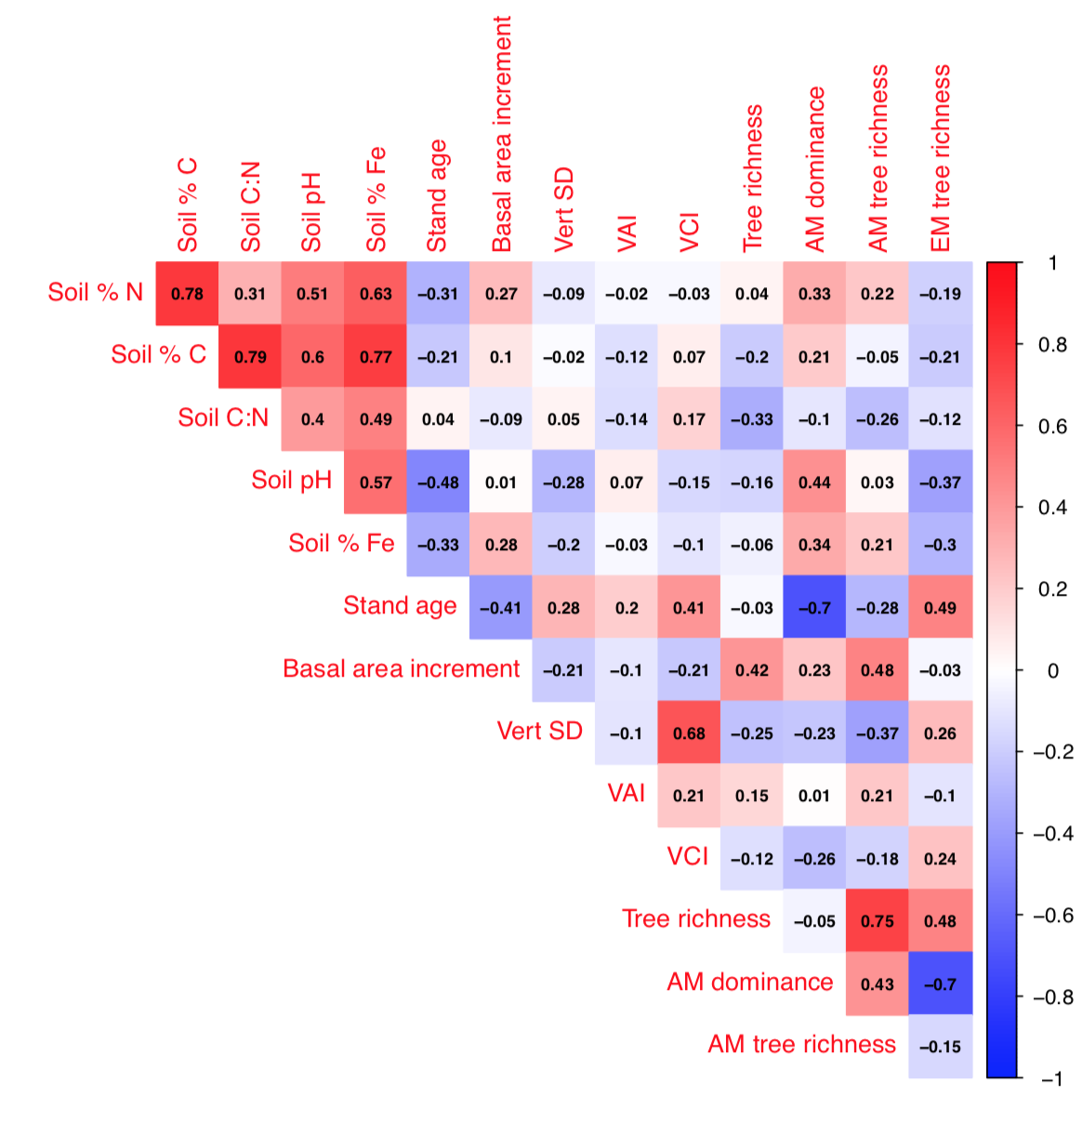

**Figure S1.** Correlations among structural diversity and environmental predictors.

**Figure S2.** Relationships between the richness of a) AM tree species and AM fungal taxa, and b) EM tree species and EM fungal taxa from soil samples collected at 0-5 cm depth and 5-10 cm depth in plots within the Indiana CFI network.

**Figure. S3.** Effects of soil pH on the alpha diversity of a) soil bacteria, b) total fungi, and c) AM and d) EM fungi, calculated with the inverse Simpson’s index. Points represent measured values of microbial richness and soil pH at 0-5 cm and 5-10 cm depth in forest soils collected across Indiana; lines represent the marginal effects of soil pH independent of the effects of other soil and vegetation factors, and are plotted only where significant. Significance determined at α=0.05.